Cache Me Outside
  - Can you find this ex-hacker turned outdoorsman? — TryHackMe Challenge

Background
Years after walking away from the scene, a retired hacker has left pieces of his identity scattered across the open internet.
At first glance, it looks like nothing more than a leaked conversation screenshot. But buried in that image is the first thread of a much larger trail. Public profiles, forgotten details, and small mistakes begin to connect into something more deliberate.
Someone wanted this person found.
Try Hack Me Room Link: Cache Me Outside
Your Assignment
You are an OSINT investigator tasked with identifying the retired hacker and tracing the clues he left behind.
Start with the conversation screenshot, follow his online presence, connect the exposed details, and use the final evidence to determine where the trail ends.
Press enter or click to view image in full size
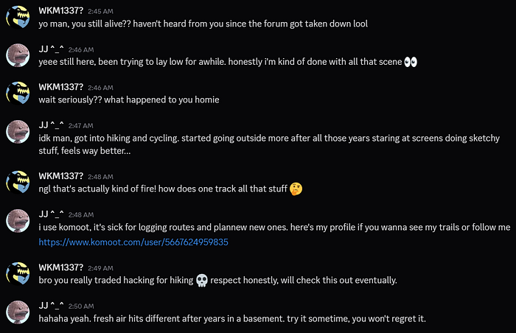
Challenge Image TryHackMe
Challenge Questions
1. What is the retired hacker’s full name ??
If you look at the screenshot, there is a Komoot link provided that leads to the hacker’s account, which contains his full name.
ANS: J** **e
2. What email address did he accidentally expose?
- The target’s profile contained a link to his GitHub account, making it a logical starting point for further investigation.
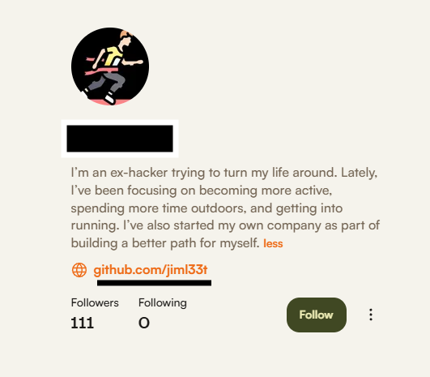
- Upon reviewing the profile, I noticed that it contained only a single repository. Opening the repository revealed a README.md file with nothing more than a simple “Hello” message. At first glance, there appeared to be little of investigative value.
- However, examining the repository history revealed that it contained only a single commit. While the commit itself does not provide any useful information, reviewing its metadata revealed his leaked email address. I explored the metadata by appending .patch at the end of the commit URL.
Press enter or click to view image in full size
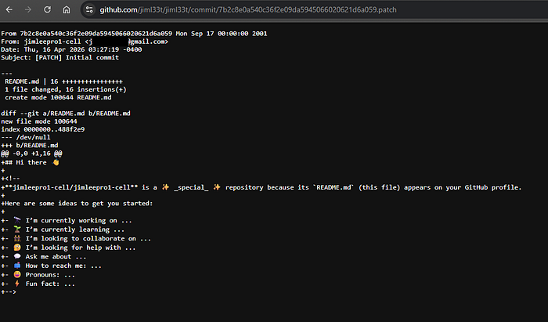
Ans: ji********@gmail.com
3. What is his phone number?
I started by reviewing every publicly available source connected to the target, including his GitHub profile, social media accounts, and any other online presence I could identify. Despite extensive searching, I was unable to find any reference to his phone number.
At this stage, passive reconnaissance had reached a dead end. Since I already had access to a valid email address from the previous challenge, I decided to move on to active reconnaissance.
I sent a test email to the address to determine whether it was still active. The goal was simple: to see if he had any automated reply set up which might reveal additional information about the target.
The approach paid off.
Shortly after sending the email, an automated response was returned. Embedded within the email signature was the target’s phone number, providing the answer to the challenge.
Answer: +40 743 *** ***
4. In which city is he located?
- While reviewing the target’s GitHub profile, I identified the username “jiml33t”. Usernames are often reused across multiple platforms, making them valuable pivots during an OSINT investigation.
- Before relying on specialised tools such as Sherlock, SpiderFoot or WhatsMyName, I performed a simple Google search using the username. This quickly revealed two accounts: Instagram and Threads.
Press enter or click to view image in full size
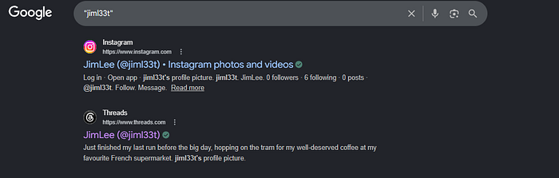
- The Instagram profile did not contain any posts, providing little investigative value. The Threads account, however, contained three posts published between 16th April and 7th May 2026.
- The most recent post, published on 7th May, included a photograph accompanied by the caption: “Just finished my last run before the big day…” Since social media posts frequently contain location clues, I focused my attention on the image itself.
- A closer inspection revealed the text “IRIGATII.RO” displayed on the wall of a nearby building. The “.RO” domain is the country-code top-level domain for Romania, suggesting that the location was somewhere within the country.
- To validate this lead, I searched Google Maps for “IRIGATII Romania.” The search returned several results, but only one location matched the exact branding visible in the image: IRIGATII.RO.
- Using Street View, I compared the surroundings shown in the photograph with the real-world location and was able to identify the exact spot where the image had been taken.
- Once the location was confirmed, determining the associated city became straightforward.
Press enter or click to view image in full size
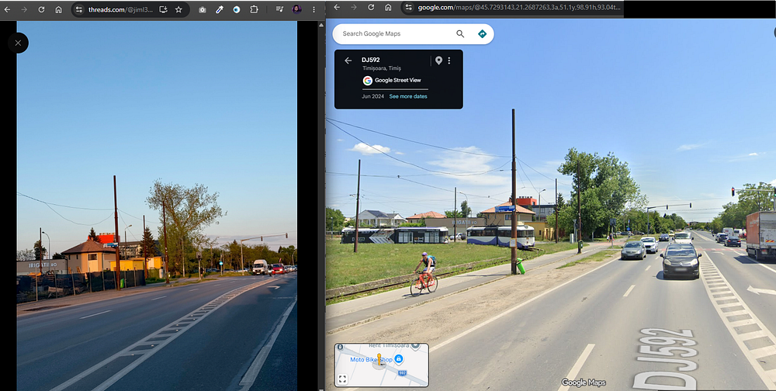
Left: Picture posted on the target’s Threads account
Right: Matching location identified through Google Maps
Answer: T*******a
5. Submit the name of the tram station where he got off on the 7th of May, 2026.
Returning to Jim’s post from 7th May on Threads, the caption provided an important clue:
“Just finished my last run before the big day, hopping on the tram for my well-deserved coffee at my favourite French supermarket.”
This statement reveals two key pieces of information. First, Jim was using the tram as his means of transportation. Second, he was travelling to what he described as his favourite French supermarket.
To identify the tram station where he got off, the first challenge was determining which supermarket he was referring to.
A review of his previous social media activity did not reveal any direct references to a preferred supermarket. Since no additional clues were available, the next step was to take a wild guess and identify the most prominent French supermarket chains operating in Romania.
A Google search led to a 2024 article published by ESM Magazine titled “Top 10 Supermarkets in Romania.” The article identified Carrefour and Auchan as two of the largest French supermarket chains in the country.
Using the location identified in the previous challenge, I plotted the surrounding area along Highway 592 and searched for nearby Carrefour and Auchan stores.
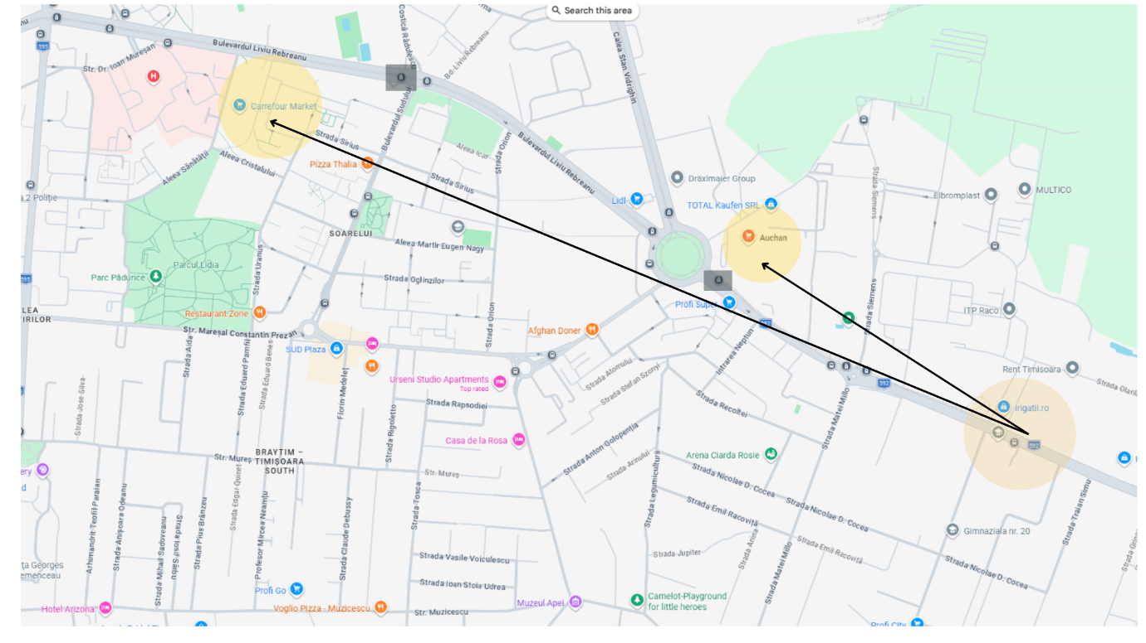
Since it was impossible to determine with certainty which supermarket Jim intended to visit, I shifted the investigation toward the tram network. For each supermarket, I identified the nearest tram station.
The stations highlighted in black boxes on the map represent the closest tram stops to each supermarket location. Comparing the station names against the answer format provided by the challenge allowed me to narrow down the possibilities and identify the correct answer.
Ans: ****a G***** Dom*****
“Fatigue is temporary. Quitting is permanent.” — Anon
___________

